Type-C Multimedia Docking Station

4K HDMI + VGA + AUDIO + USB3.0 + PD Charge Port
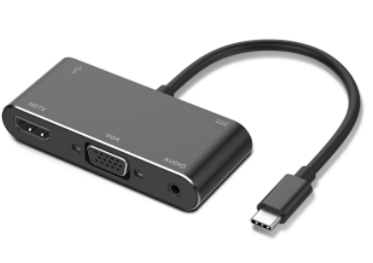
C-TC-HDMI-VGA

Descrption:
Ultra-compact, the must-have Type-C docking station for your Type-C MacBook ProTM, ChromeBookTM, DellTM XPS and other notebook or desktop computers with the next generation Type-C ports.

Instantly connect an external 4K HDMI monitor, TV or projector. Connect your legacy VGA display and connect your existing phono audio speakers and get a true multimedia experience using the high-peformance Type-C port. Stylish in design and like the complete family of Dynamode Type-C docking stations are self-powered and a must-have accessory for your Type-C enabled computers.

Feature
- Support VESA USB Type-C DisplayPort Alt Mode
- HDMI female connector, up to 4K@30Hz resolution, VGA with 1080P,with 3.5mm Jack for sound, hdmi VGA 1080 p simultaneously
- 1xport USB3.0 HUB
- Support PD function
- Aluminum housing, No need to install extra drivers, just plug and play.
- Compatible device
- New MacBook 12 inch 2015，2016
- ChromeBook Pixel ,Microsoft Surface Pro 4 ,Asus Zen AiO
- HP Pavilion x2,Lumia 950/ 950XL,Dell XPS13, Yoga 900, more type C devices
- Made of high-quality ABS, it is sturdy, lightweight and fire-resistant.

Product Code:
- Part number: C-TC-HDMI-VGA
- Weight:70g
- Barcode: 8400800036544

